Mr. Efficient

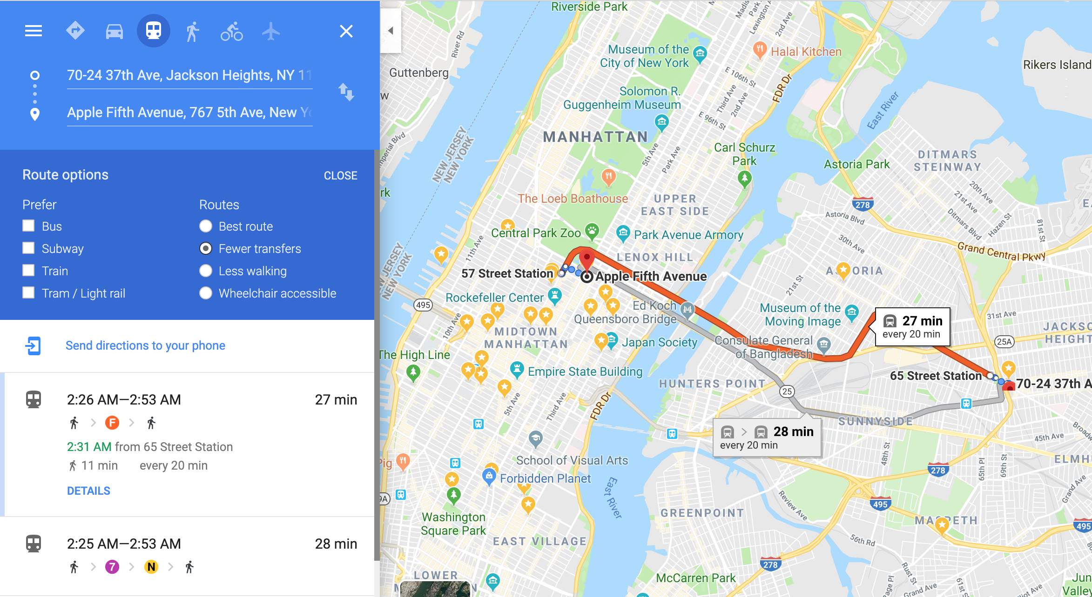

Mr. Efficient, the CEO of Efficom Inc., provides consultancy services to increase the efficiency of the workers of his clients. Mr. Efficient travels the whole country for sales and operations meetings. As a consultant of efficiency, he truly believes in efficiency in every step of life. Mr. Efficient uses his personal car for official meetings at his clients’ offices, but for personal and other travels, he also considers the public transport system to reduce cost and increase efficiency. Therefore, Mr. Efficient wants an efficient software system that, given his current and destination locations, would show him the optimal route.

**Section 1**

You’ll be given the following datasets (details are in the section “Datasets”):

1. Roadmap of the Dhaka city [Roadmap-Dhaka.csv]
2. Route map of Dhaka Metro Rail [Routemap-DhakaMetroRail.csv]
3. Route map of Bikolpo Bus [Routemap-BikolpoBus.csv]
4. Route map of Uttara Bus [Routemap-UttaraBus.csv]

**Section 2**

You’d need to compute the optimal route, dump the route in a KML (Keyhole Markup Language) file, and load the KML file on Google MyMaps or OpenStreetMap to show the route on a map. Details on how to do that is provided in the section “Output”. You will also need to output a textual description of the path (similar to driving directions)

**Section 3**

For each problem, there can be three cases. You’ll be provided a source (latitude-longitude pair) and a destination (latitude-longitude pair) for each problem. These two locations can be of any of the following cases:

1. Both of them will be located on a road-intersection/bus-stoppage/metro-station.
2. At least one of them can be located in the middle of a road.
3. At least one of them can be located outside of any road at a random point (in this case you need to assume that a rider will walk to the nearest road-intersection/bus-stoppage/metro-station at a speed of 2km/h with no cost)

**Section 4**

Solve all the problems mentioned below. For each problem you have to consider all three cases mentioned in Section 3. You can write a single solution which works for all three cases, or you may write three different solutions handling each case.

1. Find the shortest (in terms of distance) “car” route between source and destination. Assume the car moves at a constant speed.

|  |  |
| --- | --- |
| **Variable Inputs** | Source, Destination |
| **Available Modes** | Car |
| **Marks** | 1 |

1. Find the cheapest (in terms of cost) route between source and destination. Given: per kilometer cost for car is ৳20, for metro is ৳5. Assume there is no bus available.

|  |  |
| --- | --- |
| **Variable Inputs** | Source, Destination |
| **Available Modes** | Car, Metro |
| **Cost** | Car ৳20/km, Metro ৳5/km |
| **Marks** | 2 |

1. Find the cheapest (in terms of cost) route between source and destination. Given: per kilometer cost for car is ৳20, for metro is ৳5 and for bus ৳7.

|  |  |
| --- | --- |
| **Variable Inputs** | Source, Destination |
| **Available Modes** | Car, Metro, Bus |
| **Cost** | Car ৳20/km, Metro ৳5/km, Bus ৳7/km |
| **Marks** | 4 |

1. Find the cheapest (in terms of cost) route between source and destination where the rider starts from source at a given time of day (eg. 5:43 PM). Given: per kilometer cost for car is ৳20, for metro is ৳5 and for bus ৳7. Also, assume that each bus and metro runs every 15 minutes from 6 AM to 11 PM.

|  |  |
| --- | --- |
| **Variable Inputs** | Source, Destination, Starting time at Source, |
| **Available Modes** | Car, Metro, Bus |
| **Cost** | Car ৳20/km, Metro ৳5/km, Bus ৳7/km |
| **Speed** | 30km/h for every vehicle |
| **Schedule** | Bus: every 15 minutes from 6 AM to 11 PM  Metro: every 15 minutes from 6 AM to 11 PM |
| **Marks** | 8 |

1. Find the fastest (in terms of time) route between source and destination where the rider starts from source at a given time of day (eg. 5:43 PM). Assume that each bus and metro runs every 15 minutes from 6 AM to 11 PM.

|  |  |
| --- | --- |
| **Variable Inputs** | Source, Destination, Starting time at Source |
| **Available Modes** | Car, Metro, Bus |
| **Speed** | 10km/h |
| **Schedule** | Bus: every 15 minutes from 6 AM to 11 PM  Metro: every 15 minutes from 6 AM to 11 PM |
| **Marks** | 16 |

1. Find the cheapest (in terms of cost) route between source and destination where the rider starts from source at a given time of day *ts* (eg. 5:43 PM). The rider also has a pre-scheduled appointment at *td* (eg. 8:12 PM). The rider must reach the destination before *td*. Assume you have the following:

|  |  |
| --- | --- |
| **Variable Inputs** | Source, Destination, Starting time at Source, Destination reaching time |
| **Available Modes** | Car, Metro, Bus |
| **Cost** | Car ৳20/km, Metro ৳5/km, Bikalpa Bus ৳7/km, Uttara Bus ৳10/km. |
| **Speed** | Car: 20km/h, Metro 15km/h, Bikalpa Bus 10km/h, Uttara Bus 12km/h. |
| **Schedule** | Bikalpa Bus: every 20 minutes from 7 AM to 10 PM  Uttara Bus: every 10 minutes from 6 AM to 11 PM  Metro: every 5 minutes from 1 AM to 11 PM |
| **Marks** | 32 |

# Special Note:

* **There are bonus problems to be solved (worth more than the total of these 6) if any can solve all 6 of these problems. Judges will provide them, after you report that you have solved all 6 of these problems.**
* **Your solution will be based on both correctness and efficiency.**
* **Judges decision is final.**

# 

# Datasets

### 1. Roadmap of the Dhaka city [Roadmap-Dhaka.csv]

This file contains the roadmap of a portion of Dhaka city in CSV (Comma-Separated Value) format. Each line contains the data type (in this case, fixed type - DhakaStreet), a set of latitude-longitude pairs that denote a road, altitude (in this case, fixed - 0) and the length between the first lat-long pair location to the last one (in kilometers).

Sample Roadmap-Dhaka.csv file contents:

|  |  |  |  |
| --- | --- | --- | --- |
| **Data Type** | **RoadSegment-1..*n* Latitude,Longitude** | **Altitude** | **Length (kilometers)** |
| DhakaStreet | 90.363833, 23.834145, ... | 0 | 0.04683 |

### 2. Route map of Dhaka Metro Rail [Routemap-DhakaMetroRail.csv]

### 3. Route map of Bikolpo Bus [Routemap-BikolpoBus.csv]

### 4. Route map of Uttara Bus [Routemap-UttaraBus.csv]

Each of these 3 files contains the route map of a bus/train in CSV (Comma-Separated Value) format that runs through Dhaka City. Each line denotes a route, and contains the transportation name, a set of latitude-longitude pairs that denote stoppages of the route, the start location name of the route, and the final location name of the route.

Sample Routemap-xxx.csv file contents:

|  |  |  |  |
| --- | --- | --- | --- |
| **Transport Type** | **StoppageLink-1..*n* Latitute, Longitude** | **Stoppage-Start Name** | **Stoppage-*End* Name** |
| DhakaMetroRail | 90.363833, 23.834145, ... | Cantonment | Mirpur12 |
| DhakaMetroRail | 90.363843, 23.834245, ... | Mirpur12 | Mirpur10 |

# 

# Output

You need to calculate the optimal route’s lat-long pairs. Then show the optimal route on Google Maps, and output a text description of the change events leading the rider from source to destination.

Here’s a sample text description output (not corresponding to real data):

|  |
| --- |
| Problem No: 6  Source: (90.363833, 23.834145)  Destination: (90.463833, 23.534145)  Starting time at source: 6:45 PM  Destination reaching time: 8:40 PM  6:45 PM - 6:49 PM, Cost: ৳0.00: Walk from Source (90.363833, 23.834145) to (90.363824, 23.834127).  6:49 PM - 7:13 PM, Cost: ৳18.56: Ride Car from (90.363824, 23.834127) to Banani (90.363844, 23.834137).  7:15 PM - 7:29 PM, Cost: ৳10.01: Ride Uttara Bus from Banani (90.363844, 23.834137) to Mohakhali (90.363845, 23.834136).  7:50 PM - 8:03 PM, Cost: ৳20.34: Ride Bikolpo Bus from Mohakhali (90.363845, 23.834136) to Mirpur 12 (90.365845, 23.834136).  8:08 PM - 8:32 PM, Cost: ৳12.50: Ride Metro from Mirpur 12 (90.365845, 23.834136) to Uttara (90.395845, 23.834136).  8:32 PM - 8:38 PM, Cost: ৳29.48: Ride Car from Uttara (90.395845, 23.834136) to (90.395545, 23.834136).  8:38 PM - 8:42 PM, Cost: ৳0: Walk from (90.395545, 23.834136) to Destination (90.463833, 23.534145). |

Here’s how you can dump the lat-long pairs in a KML file and view on Google Maps:

Create a kml file named route.kml with the following template (replace the lat-long pairs inside the <coordinates> tag with all the lat-long pairs in your solution route, and place 0 as the third item - altitude):

|  |
| --- |
| <?xml version="1.0" encoding="UTF-8"?>  <kml xmlns="http://earth.google.com/kml/2.1">  <Document>  <Placemark>  <name>route.kml</name>  <LineString>  <tessellate>1</tessellate>  <coordinates>  90.363833,23.834145,0  90.363832,23.833879,0  </coordinates>  </LineString>  </Placemark>  </Document>  </kml> |

Once you have the KML file, load it on Google MyMaps via the following method:

1. Log into your Google account
2. Go to <https://www.google.com/mymaps>
3. Click on the ++ CREATE A NEW MAP button on the top-left of the screen.
4. Click on the + Import button-link at the left side panel (below the label “Untitled layer”).
5. Upload your just-created route.kml file. You’re done.